Teacher Preparation Notes for “Trophic Pyramids”

To begin this analysis and discussion activity, students review what happens to the atoms in the nearly 2000 pounds of food the average American eats each year. This provides a context for students to figure out why the rate of biomass production is higher for the producers than for the primary consumers in an ecosystem. Then, students construct and analyze trophic pyramids. Finally, they apply what they have learned to understanding why more resources are needed to produce meat than to produce an equivalent amount of plant food.

As background for this activity, we recommend these activities:
- “Food Webs – Understanding What Happened When Wolves Returned to Yellowstone” (https://serendipstudio.org/sci_edu/waldron/#foodweb)
- “Carbon Cycle and Energy Flow through Ecosystems” (https://serendipstudio.org/exchange/bioactivities/carboncycle)

Learning Goals
Learning Goals related to Next Generation Science Standards
Students will gain understanding of Disciplinary Core Idea LS2.B, Cycles of Matter and Energy Transfer in Ecosystems:
“Plants or algae form the lowest level of the food web. At each link upward in a food web, only a small fraction of the matter consumed at the lower level is transferred upward, to produce growth and release energy in cellular respiration at the higher level. Given this inefficiency, there are generally fewer organisms at higher levels of a food web. Some matter reacts to release energy for life functions, some matter is stored in newly made structures, and much is discarded. The chemical elements that make up the molecules of organisms pass through food webs and into and out of the atmosphere and soil, and they are combined and recombined in different ways. At each link in an ecosystem, matter and energy are conserved.”

Students engage in Scientific Practices:
- “Constructing Explanations – Apply scientific ideas, principles, and/or evidence to provide an explanation of phenomena…”
- “Developing and Using Models – Develop, revise, and/or use a model based on evidence to illustrate and/or predict the relationships between systems or between components of the system.”

Students will gain better understanding of the Crosscutting Concept, “Energy and Matter: Flows, Cycles and Conservation. Changes of energy and matter in a system can be described in terms of energy and matter flows into, out of and within that system.”

This activity helps to prepare students for the Performance Expectation:
- HS-LS2-4. “Use a mathematical representation to support claims for the cycling of matter and flow of energy among organisms in an ecosystem.”

Specific Content Learning Goals
- The biomass of an organism is the mass of the organic molecules in the organism. The rate of biomass production is highest for the producers in an ecosystem and smaller for each higher trophic level in the ecosystem.
- One major reason why the rate of biomass production is smaller for each higher trophic level is that many of the organic molecules consumed are used for cellular respiration, so carbon atoms are lost as CO₂ is released to the environment.
- The reduction in the rate of biomass production at higher trophic levels results in a trophic pyramid.
- One practical implication is that the amount of land needed to produce meat is about ten times greater than the amount of land needed to produce an equivalent biomass of plant food.
Instructional Suggestions and Background Information
To maximize student learning, we recommend that you have your students work in pairs to complete groups of related questions. Student learning is increased when students discuss scientific concepts to develop answers to challenging questions; students who actively contribute to the development of conceptual understanding and question answers gain the most (https://education.asu.edu/sites/default/files/the_role_of_collaborative_interactions_versus_individual_construction_on_students_learning_of_engineering_concepts.pdf). After students have worked together to answer a group of related questions, we recommend having a class discussion that probes student thinking and helps students to develop a sound understanding of the concepts and information covered.

If your students are learning online, we recommend that they use the Google Doc version of the Student Handout available at https://serendipstudio.org/exchange/bioactivities/trophicpyr. To answer questions 2, 4 and 5, students can either print the relevant pages, draw on those and send you pictures, or they will need to know how to modify a drawing online. They can double-click on the relevant drawing in the Google Doc, which will open a drawing window. Then, they can use the editing tools to add lines, shapes, and text boxes. You may want to revise the GoogleDoc or Word document to prepare a version of the Student Handout that will be more suitable for your students; if you do this, please check the format by viewing the PDF.

A key for this activity is available upon request to Ingrid Waldron (iwaldron@upenn.edu). The following paragraphs provide additional instructional suggestions and background biology information – some for inclusion in your class discussions and some to provide you with relevant background that may be useful for your understanding and/or for responding to student questions.
Biomass is the mass of the organic molecules in an organism. Organic molecules and water are the main types of matter in most organisms, so biomass is often estimated by weighing a dried specimen.

Question 1 should help students link their own experience to basic phenomena that play important roles in determining the shape of trophic pyramids. The annual per capita food consumption in the US is estimated as total mass (not biomass). Estimated annual per capita food consumption in the US includes 75 pounds of added fats and oils, 152 pounds of caloric sweeteners, 195 pounds of meat and fish, 200 pounds of grains, 593 pounds of dairy, and 708 pounds of fruit and vegetables (http://www.usda.gov/factbook/chapter2.pdf). Notice that the types of foods at the beginning of this list have high caloric density; foods in the last two categories weigh substantially more per calorie consumed, in large part because they contain a lot of water. In other words, more of the mass of fats, oils, and caloric sweeteners is biomass and less of the mass of dairy, fruits and vegetables is biomass.

Page 1 of the Student Handout discusses the net rate of biomass production at different trophic levels in a forest in New Hampshire (see table below). For each trophic level, the net rate of biomass production is the total mass of the organic molecules produced in a year minus the mass of the organic molecules used for cellular respiration. This is equivalent to the increase in biomass for the organisms in a trophic level, plus the amount of biomass lost to consumers or death due to other causes.
Trophic Level | Net Rate of Biomass Production
Producers | 1000 g/m²/year
Primary Consumers and Decomposers  (produce only 20% as much biomass as producers) | 200 g/m²/year
Secondary Consumers  (produce only 15% as much biomass as primary consumers and decomposers) | 30 g/m²/year
Tertiary Consumers  (produce only 10% as much biomass as secondary consumers) | 3 g/m²/year

Student answers to question 2 should include production of CO₂ by cellular respiration for primary consumers and decomposers and also defecation for the primary consumers. The relative importance of these different processes varies for different types of organisms. For example, one study found that the proportion of consumed biomass that is used for cellular respiration is ~80% for chipmunks vs. 33% for herbivorous insects. (This difference reflects the fact that chipmunks are homeotherms, whereas herbivorous insects are poikilotherms; homeothermy is metabolically expensive.) The proportion of the biomass consumed that is lost as feces is ~18% for chipmunks vs. ~50% for herbivorous insects that eat leaves. (Leaves have more cellulose and other relatively indigestible molecules than the nuts, seeds and fruits eaten by chipmunks). As a result of these differences, biomass production for chipmunks is ~2% of the biomass consumed, whereas biomass production for herbivorous insects is ~17% of the biomass consumed.

To construct trophic pyramids like the one shown on page 2 of the Student Handout, each trophic omnivore is classified in the consumer level of the main type of food they eat. The quantitative results in response to question 5a can help students understand why food chains are generally limited to 4 or 5 trophic levels. Question 5b helps students to understand that generalizations such as the “10% rule” often do not apply in specific cases. For example, the forest primary consumers plus decomposers had a rate of biomass production that was 20% of the rate for producers. One reason for this relatively high percent may be that the researchers included decomposers, which are often ignored in simplified trophic pyramids.

You should be aware that the shape of trophic pyramids is highly dependent upon the specific methodology used. You have already seen that the relative size of the first and second trophic levels for rate of biomass production depends on whether decomposers are included at the second trophic level. Although trophic pyramids for the rate of biomass production always show the classic pyramid shape with each trophic level smaller than the previous trophic level, this is not true for trophic pyramids for number of organisms or for total biomass of organisms at each trophic level. For example, a trophic pyramid for the number of individuals may show more individuals at a higher trophic level, e.g. if the organisms at the higher trophic level are smaller, such as insects feeding on trees or other plants (see figure below). Similarly, the amount of biomass may be greater at a higher trophic level, e.g. if the organisms at the higher trophic level are more long-lived, such as fish or whales feeding on plankton. This explains why, the biomass of marine consumers is roughly 5 times the biomass of marine producers (https://www.pnas.org/content/pnas/115/25/6506.full.pdf, pages 6508-6509). In conclusion, trophic pyramids for number of individuals or amount of biomass tend to show the classic pyramid shape only if organisms at different trophic levels have similar size and longevity (http://www.esa.org/history/Awards/papers/Brown_JH_MA.pdf, page 1785).

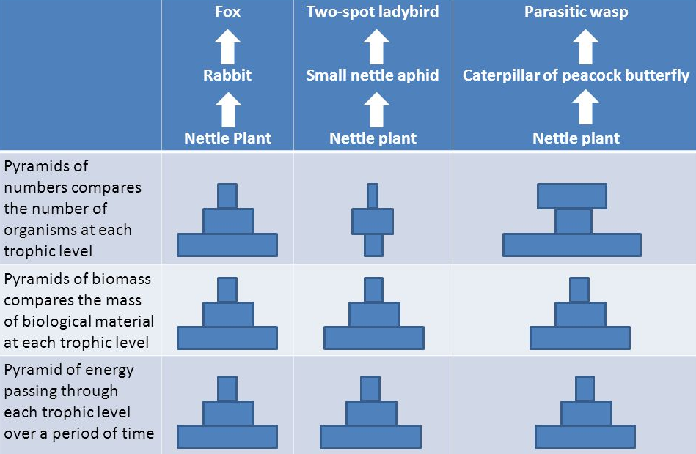
The bottom row of this figure illustrates that sometimes trophic pyramids
are presented as the energy equivalents to biomass production or biomass.
(https://slideplayer.com/slide/3461369/12/images/20/Caterpillar+of+peacock+butterfly.jpg)

If you want to discuss these issues with your students, you could add the following.

So far, we have discussed trophic pyramids that show the net rate of biomass production at different trophic levels. Another type of trophic pyramid shows the number of organisms at different trophic levels. As you can see in the figure below, comparisons of the number of organisms at different trophic levels do not always show a pyramid shape.

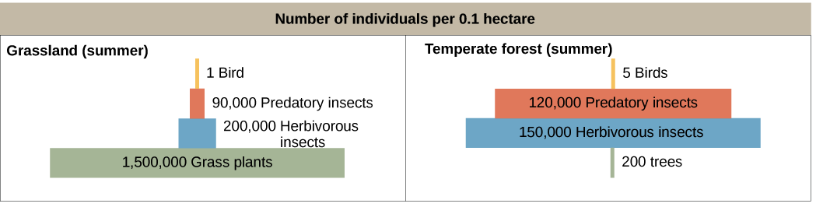

6a. Label the appropriate trophic levels in the figure as producers, primary consumers, or secondary consumers.

6b. Explain why the grassland data show a trophic pyramid with more producers than primary consumers, but the forest data show many more primary consumers than producers.

In discussing question 6 from the Student Handout, you may want to mention that eating meat from primary consumers instead of eating plant foods not only requires ~10 times as much land, but also requires ~10 times as much water and other resources. The first follow-up activity recommended below explains why eating meat also contributes much more to global warming than eating plant foods. To reinforce student understanding of why it takes so much more land to grow enough food for a person who is a carnivore, compared to the land needed to grow the food for a person who is an herbivore, you may want to show your students the PowerPoint that is available at https://slideplayer.com/slide/8731637/.

Possible Follow-Up Activities
“Food and Climate Change – How can we feed a growing world population without increasing global warming?” (https://serendipstudio.org/exchange/bioactivities/global-warming)
In the first section of this activity, students analyze information about climate change, global warming and greenhouse gases. Students learn that correlation does not necessarily imply causation, and they analyze the types of evidence that establish causal relationships. In the next two sections, students analyze carbon cycles, how food production results in the release of greenhouse gases, and the reasons why the production of different types of food results in the release of very different amounts of greenhouse gases. In the last section, students propose and research strategies to feed the world’s growing population without increasing global warming. (This activity will help students meet the Next Generation Science Standards.)

The video, “Biomagnification and the Trouble with Toxins” (https://www.youtube.com/watch?v=TZk6vcmLcKw&vl=en) shows how biomagnification arises from the same processes that produce trophic pyramids. To further student understanding of biomagnification, you can use the worksheet, “What is biological magnification?”
(https://www.biologycorner.com/worksheets/articles/biological_magnification.html). This worksheet also helps students develop reading skills.

By Drs. Ingrid Waldron and Lori Spindler, Department of Biology, University of Pennsylvania. © 2021. The Student Handout and these Teacher Preparation Notes are available at https://serendipstudio.org/exchange/bioactivities/trophicpyr.
Quotations are from http://www.nextgenscience.org/sites/default/files/HS%20LS%20topics%20combined%206.13.13.pdf
As discussed on pages 4-5 of these Teacher Notes, the numbers of organisms at each trophic level often do not show a pyramid shape, but the rate of biomass production at each trophic level does consistently show a pyramid shape. This is the reason why this activity focuses on the rate of biomass production.
To draw a shape - At the top of the page, find and click Shape. - Choose the shape you want to use. - Click and drag on the canvas to draw your shape. To insert text - At the top of the page, click Insert. - To place text inside a box or confined area, click Text Box and drag it to where you want it. - Type your text. - You can select, resize and format the word art or text box, or apply styles like bold or italics to the text. When you are done, click Save and Close.
A proxy measure of biomass is the mass of carbon in an organism; the mass of carbon is approximately half of the dry weight. Unfortunately, biomass is sometimes used to refer to the total weight of an organism; this definition is not used in this learning activity.
Information about the ecology of the Hubbard Brook Experimental Forest in New Hampshire is available in pages 1151-2 in Freeman et al., Biological Science, 2014; Scientific American, March 1978, pages 93-102; and https://hubbardbrook.org/online-book/online-book.
The figure is from https://www.khanacademy.org/science/high-school-biology/hs-ecology/trophic-levels/a/energy-flow-and-primary-productivity.

